How to Order Expanded Metal

Please review the following Ordering Information:

Please Specify:
- Specify Material.
- Specify Thickness
- Specify SWD: Short Way Diamond
- Specify LWD: Long Way Diamond
- Speficy Dimension SWD and LWD
- Quantity: number of pieces – full size or cut pieces required.
- Finish: hot-dipped galvanized, special, if any
- Special Fabrication: circle shearing, cut outs, etc., if any
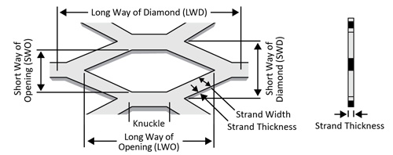Flattened (“F”) 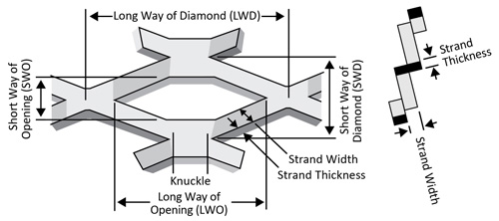Standard (“S”)

Think About:
- Application or use of product
- Physical requirements:
  - Percent of open area
  - EnvironmenT
  - Loading

